22.42: a) We need:
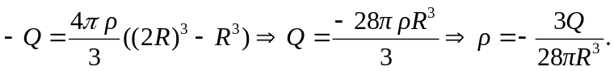
b) 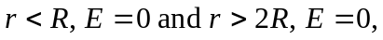 since the net charges are zero.
Substituting from (a) 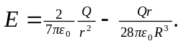

c) We see a discontinuity in going from the conducting sphere to the insulator due to the thin surface charge of the conducting sphere—but we see a smooth transition from the uniform insulator to the outside.

